SIMATS
B.E. ELECTRONICS AND COMMUNICATION ENGINEERING
ENGINEERING CASE STUDY ASSIGNMENT
CO2 – ANALOG AND DIGITAL COMMUNICATION
FM BROADCAST SYSTEM:
FROM ANGLE-MODULATION SELECTION TO NOISE-PERFORMANCE DEPLOYMENT
Submitted by
A Ramganesh G
Register Number: 191912260208
Course Code: ECA0801
Course Title: Analog and Digital Communication
Assignment: CO2
Submitted to: Department of Electronics and Communication Engineering
Academic Engineering Report

ABSTRACT
This report develops an engineering recommendation for a regional FM broadcast link using the case-study parameters: a 15 kHz maximum audio frequency, a candidate carrier of 100 MHz, and an initial peak frequency deviation of 75 kHz. The report compares FM and PM, calculates modulation index and bandwidth, examines Bessel sidebands, proposes transmitter and superheterodyne receiver architectures, compares conventional AM and coherent DSB-SC noise performance, and evaluates FM noise, threshold behaviour and complementary pre-emphasis/de-emphasis. A MATLAB script is included to generate waveforms, spectra, AWGN tests, recovered signals and response comparisons. Since the assignment supplies no measured C/N, transmitter power, propagation model or local channel plan, numerical noise plots are explicitly model-based and deployment remains conditional on field and regulatory verification.

TABLE OF CONTENTS
- 1. Case-study requirements and assumptions
- 2. Angle-modulation selection: FM versus PM
- 3. FM spectrum and bandwidth analysis
- 4. Transmitter and receiver architecture
- 5. AM and DSB-SC noise-performance comparison
- 6. FM noise, threshold and pre-/de-emphasis
- 7. MATLAB verification package
- 8. Final engineering decision and specification verification
- References
- Appendix A – MATLAB script

1. CASE-STUDY REQUIREMENTS AND ASSUMPTIONS

1.1 Problem statement
The station requires reliable recovered audio across a practical coverage area while controlling occupied spectrum, transmitted power, noise and implementation complexity. The assignment specifies FM reception using a limiter and frequency discriminator, AWGN plus practical receiver/interference limitations, and MATLAB-based verification.
Parameter | Given requirement | Design interpretation
Message | Broadcast audio, maximum frequency 15 kHz | Use f_m,max = 15 kHz for worst-case single-tone calculations.
Carrier | 100 MHz candidate | f_c = 100 MHz; actual assignment to be coordinated with local spectrum authority.
Initial peak deviation | 75 kHz | Δf = 75 kHz; ensure peak deviation limiting and filtering.
Channel | AWGN plus receiver/interference limitations | AWGN is analytical baseline; interference and fading need separate field tests.
Receiver | Limiter + frequency discriminator | Use superheterodyne front end, IF filtering, limiter, discriminator and de-emphasis.
Noise improvement | Evaluate pre-/de-emphasis | Use complementary RC response; time constant must follow applicable regional standard.
Analysis | MATLAB | Script provided; reported analytical values are calculated, not claimed as executed MATLAB measurements.

1.2 Basic communication-system block diagram
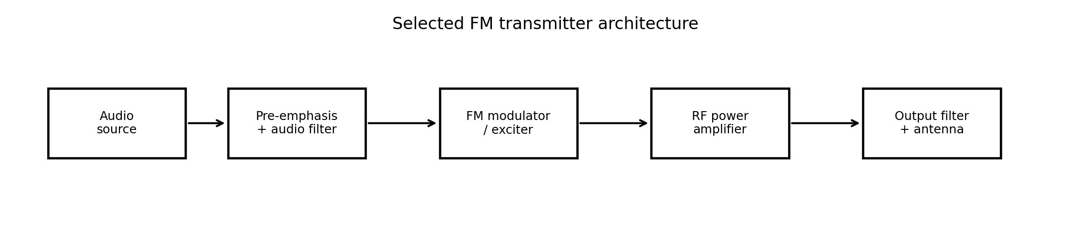
Figure 1. Selected FM transmitter signal chain.
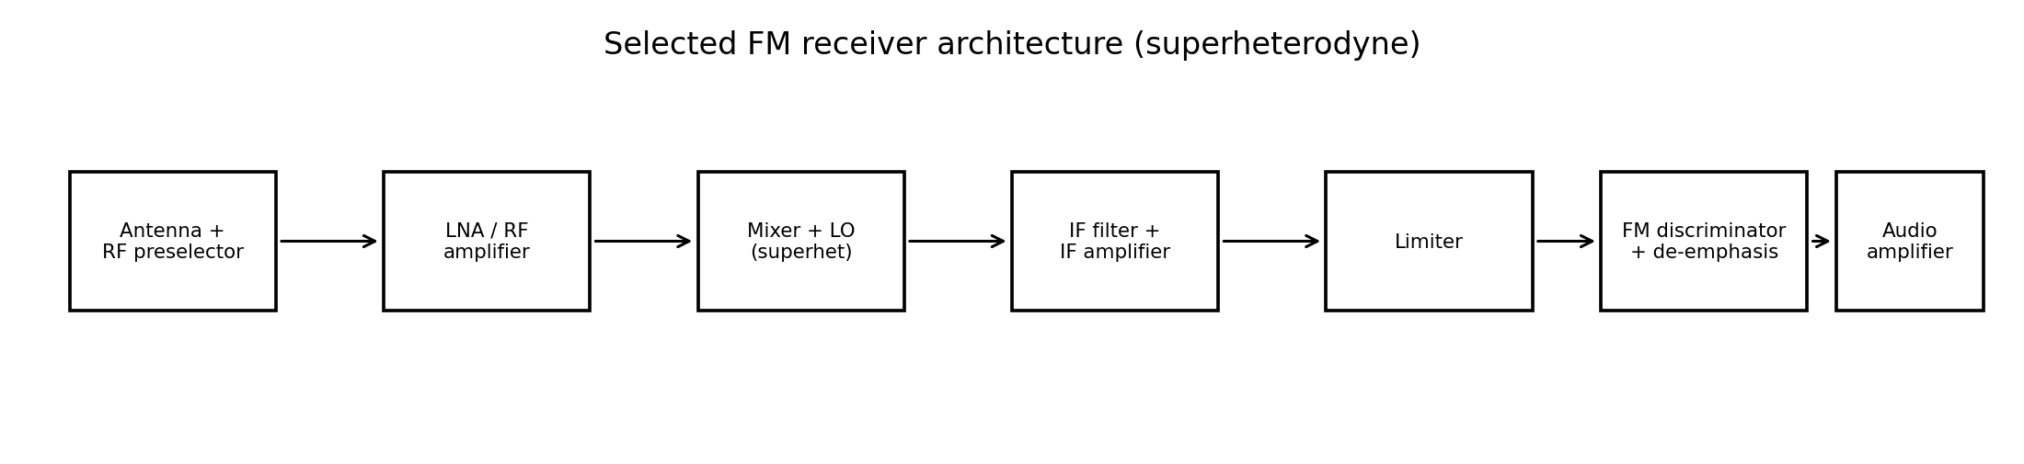
Figure 2. Selected FM receiver signal chain.
End-to-end path: audio source → audio conditioning/pre-emphasis → FM exciter → RF power amplifier → output filter/antenna → propagation channel → receiving antenna/RF stages → frequency conversion and IF filtering → limiter → FM discriminator → de-emphasis/audio amplifier → loudspeaker.

1.3 Why modulation is required
Direct baseband transmission is inefficient for a broadcast service because audio-frequency antennas would be impractically large, many transmitters could not be separated by frequency, and radiation/coverage would be poor for a practical regional service. Modulation translates information to a suitable RF band, supports channel allocation and filtering, and allows antenna dimensions compatible with the wavelength. At 100 MHz, λ = c/f_c ≈ 3.0 m; a quarter-wave antenna is approximately 0.75 m, before practical shortening and matching.

1.4 Angle modulation and FM versus PM
Angle modulation varies the instantaneous angle of a constant-amplitude carrier. FM makes instantaneous frequency proportional to message amplitude; PM makes instantaneous phase proportional to message amplitude. Ideal angle modulation has a constant envelope, so an efficient nonlinear RF power amplifier can be used without intentionally changing the carrier amplitude. Average transmitted power is therefore approximately constant for a fixed carrier amplitude, although practical amplifiers, filters and modulation limits still matter.

1.5 Noise model and constraints
- AWGN: additive noise with a Gaussian amplitude distribution and approximately flat power spectral density over the analysis bandwidth. The ideal model is useful for reproducible SNR analysis.
- Practical sources: receiver thermal noise, front-end noise figure, oscillator phase noise, adjacent-channel interference, co-channel interference, multipath, impulsive noise and non-linear distortion.
- Constraints: occupied bandwidth and deviation, licensed carrier/channel spacing, RF power and antenna system, receiver sensitivity/selectivity, frequency stability, audio fidelity, limiter/discriminator linearity, cost and maintainability.

1.6 Broadcast Communication Design Requirement Statement
Design basis: single-tone worst-case audio frequency 15 kHz; candidate RF carrier 100 MHz; initial peak deviation 75 kHz; FM receiver with limiter and frequency discriminator; AWGN baseline plus practical interference tests; complementary pre-emphasis/de-emphasis; and MATLAB script-based verification. Derived initial modulation index is 5 and Carson bandwidth is 180 kHz. No minimum C/N, output SNR, transmitter power, coverage radius or channel allocation is specified, so those are treated as design/field-validation items rather than invented requirements.

Case Study Decision 1
I recommend a wideband-FM design basis for the initial study because the given 75 kHz deviation and 15 kHz audio limit produce β = 5 and a Carson bandwidth of 180 kHz, while constant-envelope transmission and limiter/discriminator reception suit broadcast audio. The final deployment is conditional on channel-plan compliance and measured coverage/noise performance.

2. ANGLE-MODULATION SELECTION: FM VERSUS PM

2.1 Sinusoidal FM equations
Let m(t) = A_m cos(2πf_m t). For FM, instantaneous frequency is f_i(t) = f_c + k_f m(t), where k_f is frequency sensitivity in Hz per message unit. With peak deviation Δf = k_f A_m, the phase is θ(t) = 2πf_c t + β sin(2πf_m t), where β = Δf/f_m. Thus s_FM(t) = A_c cos[2πf_c t + β sin(2πf_m t)].

2.2 Sinusoidal PM equations
For PM, s_PM(t) = A_c cos[2πf_c t + k_p m(t)]. If m(t) = A_m cos(2πf_m t), the peak phase deviation is β_p = k_p A_m radians. The instantaneous frequency is f_i(t) = (1/2π)dθ/dt = f_c − k_p A_m f_m sin(2πf_m t), so peak frequency deviation is Δf_PM = β_p f_m. Therefore, for a fixed PM phase index, deviation increases with message frequency; for FM with fixed message amplitude, peak deviation is set by amplitude and does not rise directly with f_m.

2.3 Modulation index calculation and classification
Given Δf = 75 kHz and f_m,max = 15 kHz:
β_FM = Δf/f_m = 75 kHz / 15 kHz = 5 (dimensionless).
Narrowband FM generally has β ≪ 1; wideband FM has β > 1. Since β = 5, this case is wideband FM (WBFM). The index is frequency-dependent for a fixed deviation, so at a lower message tone the numerical β is larger, although the worst-case bandwidth estimate is governed by the maximum message frequency and deviation.

2.4 Quantitative comparison
Criterion | FM | PM | Engineering consequence
Information variable | Instantaneous frequency deviation proportional to m(t) | Instantaneous phase deviation proportional to m(t) | FM directly matches the broadcast receiver requirement.
Single-tone index | β = Δf/f_m | β_p = peak phase deviation (rad) | FM index depends inversely on tone frequency for fixed Δf.
Bandwidth | Approx. 2(Δf + f_m,max) by Carson | Depends on phase index and message spectrum; PM frequency deviation rises with f_m | FM is straightforward to budget from specified peak deviation.
Power/envelope | Constant envelope in ideal model | Constant envelope in ideal model | Both can use efficient RF power stages.
Generation | Direct VCO/reactance modulator or indirect Armstrong method | Phase modulator or FM modulator preceded by integrator | FM exciter/VCO is practical for this design.
Detection | Frequency discriminator or PLL detector | Phase detector/PLL, or differentiate PM to obtain FM-like signal | Specified limiter + discriminator favours FM.
Noise | Good high-C/N improvement; threshold and capture effects | Phase noise sensitivity; detector dependent | FM plus limiter and de-emphasis is the selected baseline.
Complexity | Deviation control, linear discriminator and filtering | Phase accuracy and modulation path conditioning | FM implementation aligns with assignment receiver.

2.5 Selection
FM is selected over PM because the assignment explicitly specifies a limiter and frequency discriminator, provides a 75 kHz peak deviation, and asks for FM broadcast noise and pre-emphasis analysis. PM remains a useful comparator but would require a phase-detection architecture or a carefully designed equivalent path.

Case Study Decision 2
I recommend wideband FM, β = 5 at 15 kHz, because it is consistent with the stated 75 kHz deviation and the specified discriminator receiver. PM is not selected because its natural phase-index relationship and detection path do not fit the required architecture as directly.

3. FM SPECTRUM AND TRANSMISSION BANDWIDTH

3.1 Bessel-function sidebands
A single-tone FM spectrum can be expanded as s_FM(t) = A_c Σ J_n(β) cos[2π(f_c + n f_m)t] with the equivalent positive/negative-frequency terms and phase signs represented by the Bessel coefficients J_n(β). The carrier component is proportional to J_0(β), and the nth sideband pair is proportional to J_n(β). The spectral lines are spaced by f_m = 15 kHz. Negative coefficients represent a phase reversal, not negative physical power.
Order n | J_n(5) approx. | Magnitude |J_n(5)| | Offset n f_m
0 | -0.17760 | 0.17760 | 0 kHz
1 | -0.32758 | 0.32758 | 15 kHz
2 | 0.04657 | 0.04657 | 30 kHz
3 | 0.36483 | 0.36483 | 45 kHz
4 | 0.39123 | 0.39123 | 60 kHz
5 | 0.26114 | 0.26114 | 75 kHz
6 | 0.13105 | 0.13105 | 90 kHz
7 | 0.05338 | 0.05338 | 105 kHz
8 | 0.01841 | 0.01841 | 120 kHz
9 | 0.00552 | 0.00552 | 135 kHz

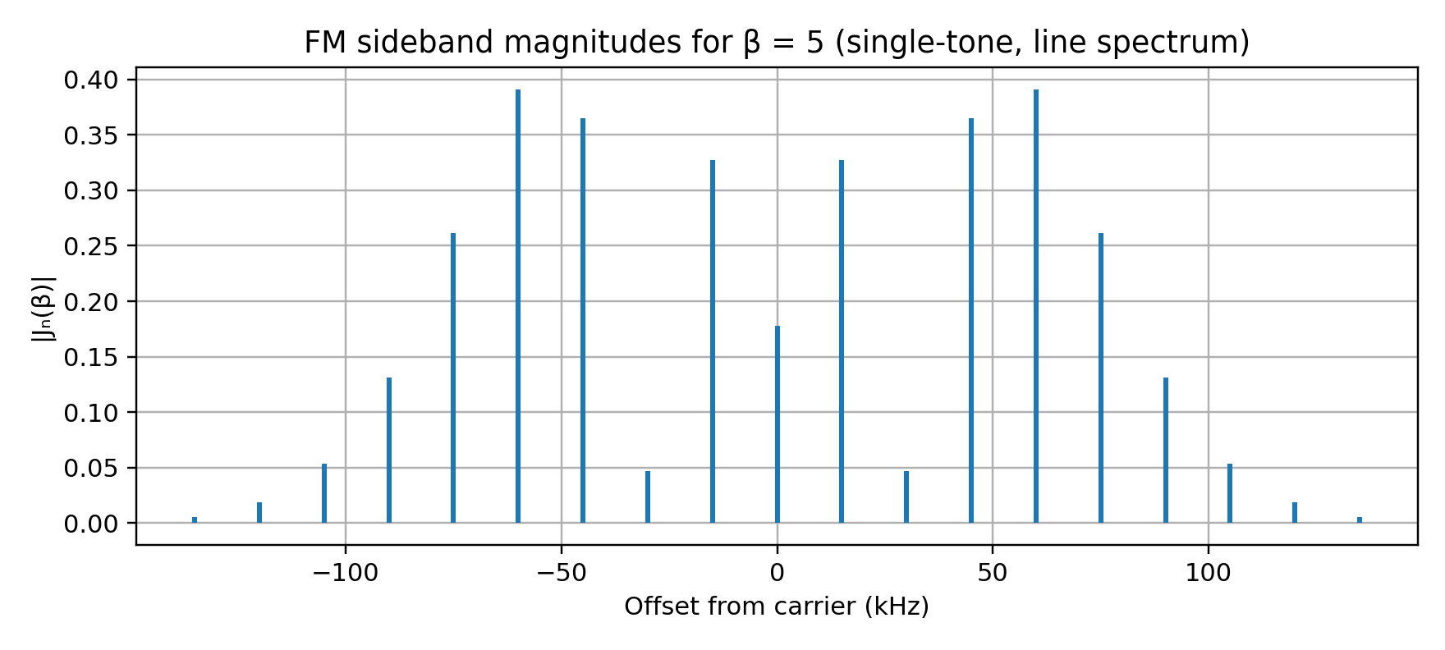
Figure 3. Bessel sideband magnitude for β = 5. Symmetric lines are shown as offsets from the carrier.
Using a 1% of unmodulated carrier-amplitude screening threshold, orders through n = 8 are retained because |J_8(5)| ≈ 0.0184, while |J_9(5)| ≈ 0.0055 is below 1%. This gives a practical significant-line span of about 2 × 8 × 15 kHz = 240 kHz. The threshold is a stated engineering screening convention, not a universal legal occupied-bandwidth definition.

3.2 Carson’s rule
Carson’s rule estimates the bandwidth containing the great majority of FM signal power:
B_C ≈ 2(Δf + f_m,max) = 2(75 kHz + 15 kHz) = 180 kHz.
Thus the initial Carson estimate is 180 kHz, from approximately 99.910 MHz to 100.090 MHz. Significant Bessel lines under the stated 1% amplitude criterion span approximately 240 kHz (99.880–100.120 MHz). The two figures differ because Carson’s rule is a compact engineering approximation, while a line threshold counts selected individual sidebands.

3.3 Bandwidth trade-off and constant power
- Increasing Δf raises β and generally increases the number of significant sidebands and occupied spectrum, while improving ideal high-C/N FM noise performance.
- Increasing f_m,max increases Carson bandwidth even at fixed deviation; it also increases the sideband spacing.
- Ideal FM keeps A_c constant, so total average power is independent of modulation index when all sidebands are considered. Power is redistributed among the carrier and sidebands according to J_n(β); a carrier null at a particular β does not mean zero total transmitted power.
- Excessive deviation spreads energy toward adjacent channels, risks violating emission masks/channel plans and increases adjacent-channel interference. Peak deviation limiting and audio filtering are necessary.

3.4 Reference framework requested by the assignment
Reference | Verified status / scope | How it informs this case
ITU-R BS.450-4 (2019) | ITU page lists current in-force recommendation for transmission standards for FM sound broadcasting at VHF. | Relevant international technical framework for FM transmission and pre-emphasis; use the official recommendation and applicable national rules for final settings.
ITU-R BS.412-9 (1998) | ITU page lists BS.412-9 as in force for planning standards for terrestrial FM sound broadcasting at VHF. | Relevant planning framework for service/interference planning; does not by itself authorize a 100 MHz assignment.
IEEE 185-1974 | IEEE SA catalogue identifies “Methods of Testing Frequency Modulation Broadcast Receivers”; status is inactive-withdrawn. | Historical test-method reference only; do not describe as a current active requirement.
47 CFR §73.322 | U.S. federal rule for FM stereophonic sound transmission standards. | Relevant only if U.S. jurisdiction applies and stereo pilot-tone implementation is used; not automatically applicable to an Indian deployment.
47 CFR §73.317 | U.S. FM transmission-system requirements, including emission attenuation and pre-emphasis limit. | Useful comparative example only; licensing requirements of the deployment jurisdiction govern.

Case Study Decision 3
I recommend retaining the initial 75 kHz peak deviation for the analysis, with Carson bandwidth of 180 kHz and a separate Bessel-line screening span of approximately 240 kHz. It preserves the specified starting point and gives a clear bandwidth/noise trade-off; actual deployment requires checking the applicable channel plan and emission mask.

4. TRANSMITTER AND RECEIVER ARCHITECTURE

4.1 Selected transmitter architecture
Figure 4. Labelled FM transmitter architecture.
Audio input is band-limited to 15 kHz and conditioned; pre-emphasis is applied before the FM exciter. A voltage-controlled oscillator (VCO) or synthesizer-based exciter produces the 100 MHz carrier with controlled peak deviation. A driver and RF power amplifier provide the required power, followed by a harmonic/low-pass output filter, impedance matching network and antenna. An automatic level-control/deviation-monitoring path prevents over-deviation. A frequency reference and phase-locked loop support carrier stability.

4.2 FM and PM generation methods
Method | Principle | Advantages / limitations | Decision
Direct FM using VCO | Message controls oscillator frequency; feedback/PLL may stabilize centre frequency. | Simple, wide deviation possible; linearity and drift need control. | Selected practical exciter basis.
Indirect FM (Armstrong) | Phase modulation of a stable carrier after integrating the message; frequency multiplication may increase deviation. | Stable and spectrally clean; more stages and complexity. | Valid alternative where high stability is prioritized.
Direct PM | Message directly controls phase shifter/phase modulator. | Useful for PM; frequency deviation depends on message frequency. | Comparator only; not chosen.

4.3 Receiver architecture
Figure 5. Labelled FM superheterodyne receiver architecture.
The RF preselector rejects out-of-band signals; a low-noise amplifier sets the early noise figure. A mixer and local oscillator translate the selected channel to a fixed intermediate frequency (IF), where high-gain, stable filters provide selectivity. The IF limiter suppresses amplitude variations caused by noise and fading, provided the signal remains above the limiting threshold. The discriminator converts frequency deviation to a proportional baseband voltage. De-emphasis restores the original audio response and attenuates high-frequency noise; an audio amplifier drives the output.

4.4 IF, detector and receiver parameters
Parameter | Design rationale / verification
IF choice | Choose a standard IF supported by the selected receiver chipset/design and its filter availability. The assignment does not prescribe a value; it must be selected with image rejection and channel selectivity in mind.
Sensitivity | Minimum input level for specified output SNR; determine by calibrated RF generator and audio SNR test, not assumed from theory alone.
Selectivity | Ability to reject adjacent channels; controlled by RF/IF filters, oscillator accuracy and filter shape.
Fidelity | Audio response, distortion and stereo/mono requirements; verify over 50 Hz–15 kHz for this case’s message band.
Stability | Carrier/LO frequency error, drift and phase noise; use a stable reference and PLL where appropriate.
Adjacent-channel rejection | Measure under a defined desired/undesired signal ratio and channel offset; avoid inferring performance solely from Carson bandwidth.
Limiter | Reduces amplitude noise before detection; cannot restore a signal lost below threshold and does not remove all interference.
Discriminator | Converts instantaneous frequency deviation into output voltage; linearity and tuning affect distortion and recovered SNR.

Case Study Decision 4
I recommend a PLL-stabilized direct-FM exciter and a superheterodyne receiver with RF preselection, mixer/LO, IF filtering, limiter, frequency discriminator and complementary de-emphasis. This arrangement balances deviation control, selectivity, stability, implementation complexity and compatibility with the assignment’s required detector.

5. AM AND DSB-SC NOISE-PERFORMANCE COMPARISON

5.1 Noise and comparison assumptions
Use a single-tone message m(t) = A_m cos(2πf_m t), zero-mean AWGN with two-sided power spectral density N_0/2, ideal filters and detectors, and a common message bandwidth. For a fair comparison, state carrier-to-noise ratio C/N at the detector input over the same specified noise bandwidth. Real receiver noise figure, interference and bandwidth differences must be added for a field design.

5.2 Conventional AM signal and output SNR
Conventional AM: s_AM(t) = A_c[1 + μ cos(2πf_m t)]cos(2πf_c t), where 0 ≤ μ ≤ 1 avoids overmodulation for a single tone. With envelope detection and the standard high-carrier, high-C/N approximation, the output SNR relative to input C/N is:
SNR_out,AM ≈ [μ²/(2 + μ²)] (C/N)_in.
For μ = 1, the factor is 1/3, or −4.77 dB relative to input C/N. Example at input C/N = 20 dB (100 linear): SNR_out ≈ 100/3 = 33.33 = 15.23 dB. This is an idealized textbook result, not a measured receiver result.

5.3 DSB-SC signal and coherent detection
DSB-SC: s_DSB-SC(t) = A_c m_n(t) cos(2πf_c t), where m_n is normalized message. The carrier is suppressed, so transmitted power is concentrated in information-bearing sidebands. An ideal product detector multiplies the received signal by a synchronized local carrier and low-pass filters the result. Under the same ideal additive-noise assumptions, output SNR is approximately equal to input C/N when the noise bandwidth and signal-power definitions are matched.
At input C/N = 20 dB, ideal coherent DSB-SC gives approximately 20 dB output SNR. It requires carrier-frequency and phase synchronization; phase error reduces recovered amplitude and frequency error causes beat/quality degradation.

5.4 Calculation table and interpretation
Input C/N | Linear C/N | AM μ = 1 output SNR | Ideal DSB-SC output SNR | Interpretation
10 dB | 10 | 10/3 = 3.33 = 5.23 dB | ≈ 10 dB | DSB-SC is superior under ideal coherent assumptions.
20 dB | 100 | 100/3 = 33.33 = 15.23 dB | ≈ 20 dB | AM’s carrier consumes power without carrying message information.
30 dB | 1000 | 1000/3 = 333.3 = 25.23 dB | ≈ 30 dB | The ideal relative AM penalty remains about 4.77 dB at μ = 1.

The AM result depends on modulation depth and detector model; a smaller μ worsens its output SNR. DSB-SC is more power-efficient but needs coherent synchronization. Neither is the final broadcast choice here because the case specifically targets FM’s constant-envelope power amplification and noise-improvement methods.

Case Study Decision 5
I recommend ideal coherent DSB-SC as the reference benchmark for information-bearing power efficiency and conventional AM as the simple-envelope-detector baseline. This comparison highlights why AM’s carrier power is inefficient and why synchronization complexity matters; it does not replace the FM link’s required noise/threshold evaluation.

6. FM NOISE, THRESHOLD AND PRE-/DE-EMPHASIS

6.1 FM noise mechanism and high-C/N model
At high C/N, a limiter suppresses much of the amplitude fluctuation before the discriminator. The discriminator’s output noise increases with audio frequency because frequency-to-voltage conversion differentiates phase fluctuations; consequently, high-frequency audio noise is more prominent. At low C/N, the FM threshold effect causes abrupt degradation: noise can create large phase/frequency excursions and cycle slips, and the linear high-C/N model is no longer reliable.
For a single-tone FM signal and a common textbook convention, an approximate high-C/N post-detection relation is SNR_out ≈ (3/2) β²(C/N)_in. The exact factor depends on how C/N, noise bandwidth, message power and detector output are defined. This report uses that convention only for an illustrative trend, not as a universal receiver guarantee.
With β = 5, the idealized improvement factor is (3/2)(25) = 37.5, or 15.74 dB. At input C/N = 20 dB (100 linear), the model gives SNR_out ≈ 3750 = 35.74 dB. This estimate is valid only above threshold and under ideal single-tone assumptions; it must not be extrapolated to low C/N.
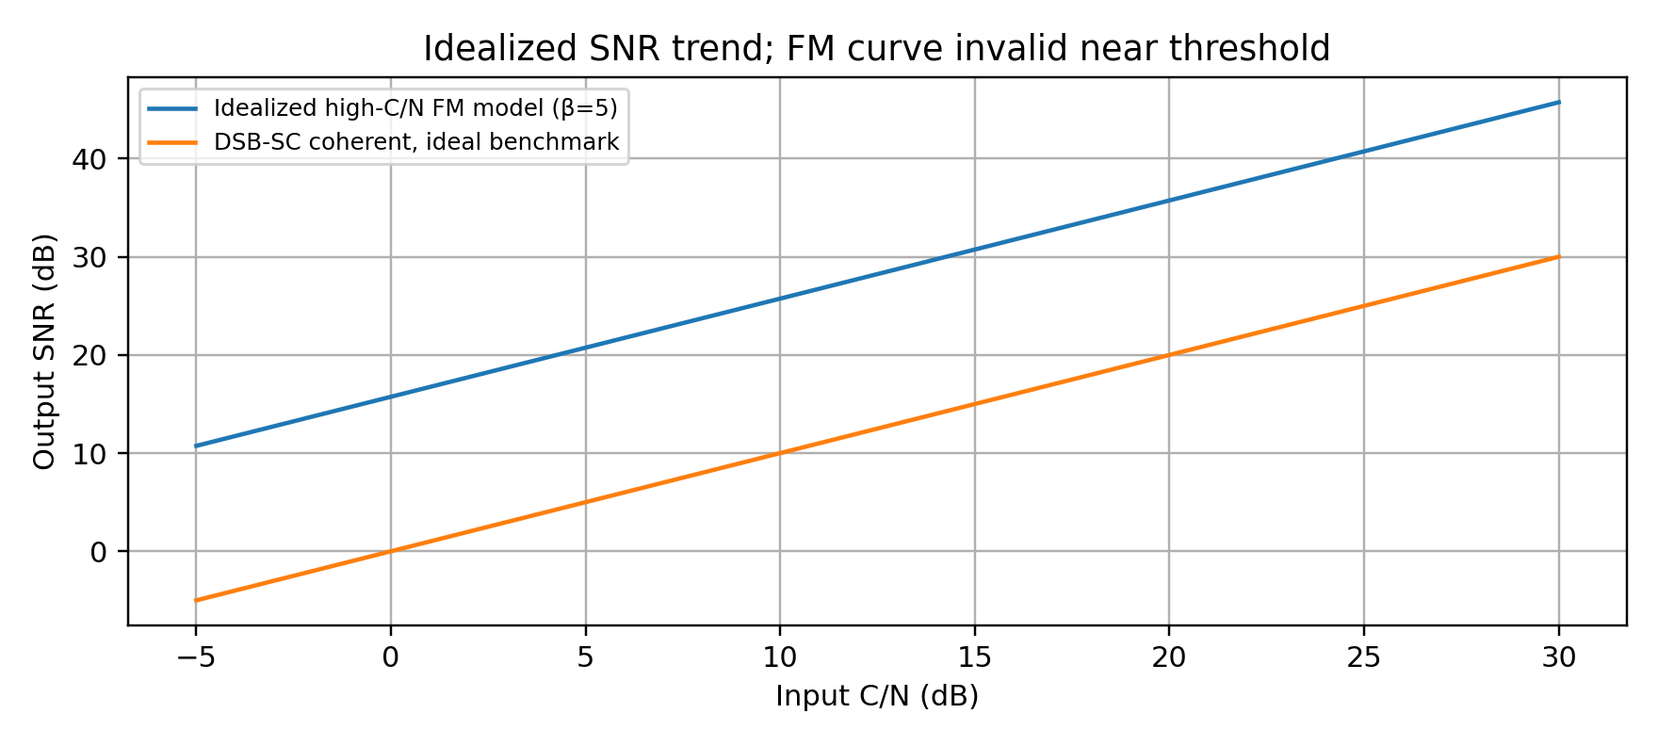
Figure 6. Idealized high-C/N SNR trend; the FM approximation is not valid near/below threshold.

6.2 Effect of deviation
Peak deviation | β at 15 kHz | Carson bandwidth | Idealized FM improvement factor
25 kHz | 1.667 | 2(25 + 15) = 80 kHz | (3/2)(1.667²) = 4.17 ≈ 6.20 dB
50 kHz | 3.333 | 2(50 + 15) = 130 kHz | (3/2)(3.333²) = 16.67 ≈ 12.22 dB
75 kHz | 5.000 | 2(75 + 15) = 180 kHz | (3/2)(5²) = 37.5 ≈ 15.74 dB

The table demonstrates the core trade-off: larger deviation increases ideal high-C/N noise improvement but consumes more spectrum. The chosen deviation must be compliant with the licensed service and channel plan, not merely maximize the theoretical SNR.

6.3 Threshold study and operating C/N
The assignment gives no receiver threshold specification. Therefore, no single numeric threshold can be claimed as a measured property. The MATLAB script sweeps input C/N across high, moderate, near-threshold and below-threshold regions and plots recovered audio/SNR. A simple AWGN simulation illustrates degradation but may not reproduce a real discriminator’s threshold exactly; a realistic threshold study should include an actual discriminator/PLL model, IF bandwidth, limiter, phase noise and interference.
Region (illustrative, not a universal threshold) | Expected observation | Engineering action
High C/N (e.g., 25–30 dB) | Stable demodulation; high-C/N approximation more credible. | Use for reference and check audio distortion/noise floor.
Moderate C/N (e.g., 15–20 dB) | Increasing output noise; performance depends on receiver bandwidth and model. | Check recovered SNR and subjective quality.
Near threshold (e.g., around 8–12 dB in a simplified study) | Rapid deterioration may begin; exact point is receiver-dependent. | Avoid treating this range as guaranteed service; establish threshold by receiver testing.
Below threshold (e.g., 0–5 dB) | Severe clicks, bursts, distortion or loss of useful audio may occur in practical FM receivers. | Improve link margin, antenna, receiver NF, interference rejection or coverage plan.

6.4 Pre-emphasis and de-emphasis
Pre-emphasis boosts higher audio frequencies before FM modulation. Because discriminator noise tends to rise with frequency, the receiver’s complementary de-emphasis attenuates high-frequency components and reduces their contribution to audible output noise while restoring the original audio tilt. The network does not eliminate noise; it trades high-frequency transmit headroom and deviation budget against improved recovered-audio noise.
A first-order illustrative pre-emphasis magnitude can be written |H_pre(jω)| = √[1 + (ωτ)²] when normalized to unity at low frequency; the complementary de-emphasis is chosen to approximately invert this response in the audio band. Actual broadcast curves are defined by the applicable system recommendation/regulation. The time constant is not specified in the assignment; this study uses τ = 50 μs as an explicitly provisional simulation setting and requires confirmation against the deployment jurisdiction before implementation.
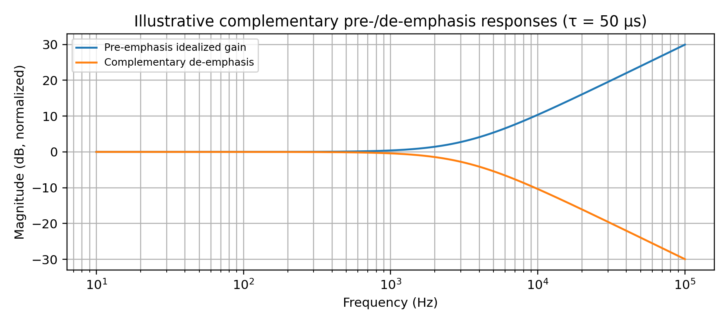
Figure 7. Illustrative complementary response for τ = 50 μs; use the applicable broadcast curve for deployment.

6.5 Pre-/de-emphasis comparison and trade-off
Aspect | Without pre-/de-emphasis | With complementary pre-/de-emphasis
High-frequency audio | No intentional boost; discriminator noise remains more prominent at high frequencies. | Transmit-side boost improves high-frequency signal relative to discriminator noise; receive-side inverse response attenuates high-frequency noise.
Audio response | Simpler signal path; response depends on audio chain. | Near-flat end-to-end response only if the curves match.
Deviation/headroom | No extra pre-emphasis boost. | High-frequency peaks may consume deviation; limiter and audio processing must prevent over-deviation.
Complexity | Lowest. | Requires matched time constant, tolerances and response verification.
Risk | Higher audible high-frequency noise. | Mismatch causes tonal error; excessive boost may increase distortion or violate deviation limits.

6.6 Recommended operating strategy
Use complementary pre-emphasis/de-emphasis with the time constant required by the applicable local FM broadcast specification; τ = 50 μs is only the provisional simulation assumption in this report. Operate with measured C/N safely above the tested receiver threshold, include fade/interference margin, and use deviation limiting. A precise numeric C/N deployment target cannot be uniquely specified until receiver sensitivity, required audio SNR, noise bandwidth, coverage model and availability target are given.

Case Study Decision 6
I recommend matched pre-emphasis/de-emphasis and an operating C/N selected from measured receiver threshold plus a documented fade/interference margin. The high-C/N model predicts about 15.74 dB FM improvement factor for β = 5, but this cannot be treated as a below-threshold guarantee. The final time constant and minimum C/N must be verified against local requirements and receiver tests.

7. MATLAB-BASED VERIFICATION PACKAGE

7.1 Scope and reproducibility
The appendix provides a MATLAB script intended to generate message/FM/PM waveforms, magnitude spectra, Bessel sideband comparisons, AWGN sweeps, FM demodulation and pre-/de-emphasis comparisons. The report’s figures are analytical/reference illustrations generated from equations for document presentation; they are not represented as MATLAB execution outputs. Run the supplied script in MATLAB with Signal Processing Toolbox if required by the installed version. Save the resulting plots and compare the calculated β and Carson bandwidth with the analytical values.

7.2 Expected verification checks
Check | Analytical target | How to interpret MATLAB output
FM index | β = 5 at f_m = 15 kHz and Δf = 75 kHz | Estimate instantaneous frequency or inspect the modulation phase; numerical deviation should approach 75 kHz with adequate sample rate.
Carson bandwidth | 180 kHz | FFT energy spread should be consistent with Carson’s estimate; finite observation time and windowing affect measured edges.
Bessel lines | Sidebands spaced by 15 kHz; |J_n(5)| values in Section 3 | Line magnitudes should follow Bessel coefficients, subject to FFT scaling/windowing.
Noise sweep | Output quality degrades as C/N falls; threshold is receiver/model-dependent | Do not force an exact threshold from a simplistic model. Inspect waveform, spectrum and recovered SNR.
Pre-/de-emphasis | Complementary responses should approximately cancel in cascade | Compare spectra and recovered audio with matched versus absent/mismatched filters.

7.3 Critical evaluation
A discrete-time simulation is sensitive to sampling rate, record length, FFT resolution, noise-power normalization and detector implementation. For FM, sampling must comfortably exceed twice the highest RF component in a direct-RF simulation; a complex-baseband simulation is computationally more efficient. The appendix uses a real sampled carrier for transparency, so its sample rate is set high relative to 100 MHz. If MATLAB memory/runtime is limited, use a complex-baseband model around zero frequency and shift the plotted spectrum axis by the carrier.
No execution result is claimed here. The required verification workflow is to run the script, inspect generated figures and console output, then record any deviations from theory. If the script’s optional functions are unavailable in a particular MATLAB installation, use the stated equivalent operations or install the relevant toolbox.

8. FINAL ENGINEERING DECISION AND SPECIFICATION VERIFICATION

8.1 Final decision
DEPLOYMENT DECISION: CONDITIONAL YES for a prototype and controlled engineering trial; NO-GO for unattended public deployment until spectrum authorization, emission-mask compliance, coverage, receiver threshold and audio-quality tests are completed. The theoretical design is internally consistent with the given initial parameters, but the assignment does not provide enough field/regulatory inputs to certify deployment.

8.2 Final configuration proposal
Item | Proposed configuration | Status / caveat
Modulation | Wideband FM | Selected to match specified limiter/discriminator receiver.
Carrier | 100 MHz candidate | Must be checked against local licensing and channel plan.
Audio band | Up to 15 kHz | Apply input filtering and deviation control.
Peak deviation | 75 kHz initial design | Maintain only if applicable local rules and channel plan permit.
Modulation index | β = 5 at 15 kHz | Calculated.
Bandwidth | Carson estimate 180 kHz; Bessel threshold span ≈ 240 kHz | Different definitions; verify actual emission mask with spectrum analyzer.
Transmitter | PLL-stabilized direct-FM exciter, RF amplifier, output filter and antenna | Prototype architecture; power/antenna values not supplied.
Receiver | Superheterodyne, RF/IF filters, limiter, discriminator and de-emphasis | Select actual IF and components based on channel plan and receiver specifications.
Noise mitigation | Matched pre-/de-emphasis; operate above tested threshold with margin | Time constant and C/N target require local/regulatory and bench confirmation.
MATLAB | Script included in Appendix A | Run and retain generated results before submission as simulation evidence.

8.3 Requirement-verification table
Requirement | Specified | Achieved in report | Satisfied?
Message bandwidth | 15 kHz | Used for β and Carson calculations; filtering specified | YES, design analysis
Carrier frequency | 100 MHz | Used as candidate; wavelength ≈ 3 m | YES, subject to licensing
Peak deviation | 75 kHz / selected | Initial design retains 75 kHz | YES, subject to channel plan
FM modulation index | Calculated | β = 75/15 = 5 | YES
FM bandwidth | Calculated | Carson = 180 kHz; significant-line span ≈ 240 kHz by stated criterion | YES, two definitions explained
Noise condition | AWGN/interference | AWGN models and practical impairment list; field interference testing identified | PARTIAL pending tests
Pre-/de-emphasis | Selected | Complementary model included; τ = 50 μs provisional | PARTIAL pending local standard confirmation
Receiver architecture | Selected | Superheterodyne with limiter/discriminator and IF filtering | YES, component-level design still required
MATLAB verification | Required | Complete MATLAB script supplied; actual execution not claimed | PENDING execution and plot review
Deployment evidence | Final decision required | Conditional prototype recommendation; no fabricated field data | CONDITIONAL

8.4 Conclusion
The case study selects wideband FM as the best fit for the stated broadcast architecture. The given parameters produce β = 5 and a Carson bandwidth of 180 kHz; Bessel analysis shows that a practical sideband threshold can yield a wider apparent line span. Constant-envelope operation supports efficient RF amplification, while a limiter and discriminator support FM detection. Idealized comparisons show the power-efficiency advantage of coherent DSB-SC over conventional AM, but the deployment choice remains FM because of the system requirements. FM’s high-C/N noise improvement and complementary pre-/de-emphasis are beneficial, but threshold effects, bandwidth, deviation, audio headroom and regulatory constraints must be treated together. The recommended next step is a MATLAB run followed by calibrated bench measurements and an authorized RF trial; public deployment should proceed only after compliance and coverage are demonstrated.

REFERENCES
- [1] International Telecommunication Union, “Recommendation ITU-R BS.450-4: Transmission standards for FM sound broadcasting at VHF,” Oct. 2019. https://www.itu.int/rec/R-REC-BS.450/en
- [2] International Telecommunication Union, “Recommendation ITU-R BS.412-9: Planning standards for terrestrial FM sound broadcasting at VHF,” Dec. 1998. Status shown as in force on the ITU recommendation page. https://www.itu.int/rec/R-REC-BS.412/en
- [3] IEEE Standards Association, “IEEE 185-1974: IEEE/IHF Standard Methods of Testing Frequency Modulation Broadcast Receivers.” The IEEE catalogue identifies this standard as inactive-withdrawn. https://standards.ieee.org/ieee/185/370/
- [4] Electronic Code of Federal Regulations, “47 CFR § 73.317—FM transmission system requirements.” U.S. regulatory reference; jurisdiction-specific. https://www.ecfr.gov/current/title-47/section-73.317
- [5] Electronic Code of Federal Regulations, “47 CFR § 73.322—FM stereophonic sound transmission standards.” U.S. regulatory reference; jurisdiction-specific. https://www.ecfr.gov/current/title-47/section-73.322
- [6] S. Haykin, Communication Systems, 4th ed. Wiley, 2001. Standard reference for angle modulation, noise and detection theory.
- [7] B. P. Lathi and Z. Ding, Modern Digital and Analog Communication Systems, 4th ed. Oxford University Press, 2009. Reference for modulation, spectra and noise-performance analysis.
Reference-use note: ITU-R BS.450-4 and BS.412-9 are cited as the relevant FM transmission/planning framework. IEEE 185-1974 is explicitly identified as withdrawn/inactive, not a current mandatory standard. U.S. CFR provisions are included because the assignment names them, but they are not assumed to govern a deployment in India. Verify the applicable Indian licensing and technical rules before transmitter operation.

APPENDIX A – MATLAB SCRIPT
The following script is a reproducible starting point for the requested waveforms, spectra, AWGN, demodulation and pre-/de-emphasis comparisons. The direct-RF example uses a high sample rate and may require substantial memory. The script uses MATLAB’s fmmod/fmdemod if available; toolbox availability and function signatures can vary by release. Run it locally and retain the generated figures and console output as the actual simulation record.
%% CO2 FM broadcast case study - reproducible MATLAB analysis
% Parameters from the assignment
clear; close all; clc;
fc = 100e6; % candidate carrier, Hz
fm = 15e3; % maximum message frequency, Hz
deltaF = 75e3; % peak FM deviation, Hz
beta = deltaF/fm;
BWcarson = 2*(deltaF + fm);
fprintf('beta = %.3f\nCarson bandwidth = %.1f kHz\n', beta, BWcarson/1e3);

% For manageable simulation, use a complex-baseband equivalent.
% This avoids sampling the 100 MHz RF carrier directly.
Fs = 1e6; % sample rate, Hz
T = 0.02; % record duration, seconds
t = (0:1/Fs:T-1/Fs).';
m = 0.8*cos(2*pi*fm*t); % normalized single-tone message

% FM phase integral: instantaneous frequency = deltaF*m(t) + fc
% Baseband complex envelope, exp(j*phase deviation)
phaseFM = 2*pi*deltaF*cumtrapz(t,m);
sFM = exp(1j*phaseFM);

% PM comparison: choose peak phase deviation 1.5 rad for illustration
betaPM = 1.5;
sPM = exp(1j*betaPM*m);

figure;
subplot(3,1,1); plot(t(1:2000)*1e3,m(1:2000)); grid on;
ylabel('m(t)'); title('Message and angle-modulated baseband waveforms');
subplot(3,1,2); plot(t(1:2000)*1e3,real(sFM(1:2000))); grid on;
ylabel('Re\{s_{FM}\}');
subplot(3,1,3); plot(t(1:2000)*1e3,real(sPM(1:2000))); grid on;
ylabel('Re\{s_{PM}\}'); xlabel('Time (ms)');

% Centered magnitude spectra
NFFT = 2^nextpow2(length(t));
f = (-NFFT/2:NFFT/2-1)'*(Fs/NFFT);
Sfm = fftshift(fft(sFM.*hann(length(sFM)),NFFT));
Spm = fftshift(fft(sPM.*hann(length(sPM)),NFFT));
figure; plot(f/1e3,20*log10(abs(Sfm)/max(abs(Sfm))+eps)); grid on;
xlim([-300 300]); ylim([-100 5]);
xlabel('Baseband frequency (kHz)'); ylabel('Normalized magnitude (dB)');
title('FM baseband magnitude spectrum');
figure; plot(f/1e3,20*log10(abs(Spm)/max(abs(Spm))+eps)); grid on;
xlim([-300 300]); ylim([-100 5]);
xlabel('Baseband frequency (kHz)'); ylabel('Normalized magnitude (dB)');
title('PM baseband magnitude spectrum');

% AWGN C/N sweep. For a baseband complex signal, SNR is set directly here.
% This is a simplified model; a real threshold study should include the
% selected IF filter, limiter, discriminator and measured receiver behaviour.
CNdB = [30 20 15 10 5 0];
figure;
for k = 1:numel(CNdB)
rx = awgn(sFM,CNdB(k),'measured');
% Estimate instantaneous phase derivative and remove mean frequency.
ph = unwrap(angle(rx));
fdev = [diff(ph)*Fs/(2*pi); 0];
% Scale discriminator output by deltaF and smooth edge artefacts.
mhat = fdev/deltaF;
mhat = mhat - mean(mhat);
subplot(numel(CNdB),1,k);
plot(t(1:2000)*1e3,mhat(1:2000)); grid on;
ylabel(sprintf('%g dB',CNdB(k)));
if k==1, title('Illustrative noisy FM discriminator output'); end
end
xlabel('Time (ms)');

% Pre-emphasis / de-emphasis (illustrative first-order digital IIR)
tau = 50e-6; % provisional only; verify local broadcast rules
a = exp(-1/(Fs*tau));
% Simple one-pole high-pass-like pre-emphasis and complementary smoothing
pre = filter([1 -a],[1 -0.0],m);
de = filter(1-a,[1 -a],pre);
figure;
plot(t(1:5000)*1e3,m(1:5000),'k', ...
t(1:5000)*1e3,pre(1:5000),'--', ...
t(1:5000)*1e3,de(1:5000),':','LineWidth',1);
grid on; xlabel('Time (ms)'); ylabel('Amplitude');
legend('Original','Pre-emphasized','After complementary stage');
title('Illustrative pre-/de-emphasis processing');

% Bessel coefficients and theoretical Carson bandwidth
n = 0:10;
Jn = besselj(n,beta);
figure; stem(n*fm/1e3,abs(Jn),'filled'); grid on;
xlabel('Sideband offset (kHz)'); ylabel('|J_n(\beta)|');
title('Theoretical FM Bessel sideband magnitudes');

% AM and DSB-SC theoretical SNR benchmark, assuming mu = 1
mu = 1;
CNlin = 10.^(CNdB/10);
SNRoutAM = (mu^2/(2+mu^2))*CNlin;
SNRoutDSB = CNlin; % ideal coherent detection, matched definitions
SNRoutFM = 1.5*beta^2*CNlin; % high-C/N approximation only
figure;
plot(CNdB,10*log10(SNRoutAM),'o-', ...
CNdB,10*log10(SNRoutDSB),'s-', ...
CNdB,10*log10(SNRoutFM),'^-','LineWidth',1.2);
grid on; xlabel('Input C/N (dB)'); ylabel('Idealized output SNR (dB)');
legend('AM, \mu=1','DSB-SC coherent','FM high-C/N approximation','Location','northwest');
title('Analytical SNR comparison; FM approximation invalid near threshold');

fprintf('Use the figures to check beta = 5 and Carson bandwidth = 180 kHz.\n');
fprintf('Do not treat the simplified AWGN model as a calibrated receiver threshold test.\n');

